# TITLE PAGE

**DESIGN AND IMPLEMENTATION OF AN AI BASED VOICE CONTROLLED NEWS APPLICATION**

**BY**

**SIMON PIUS**

**ST/CS/ND/21/077**

**DEPARTMENT OF COMPUTER SCIENCE,**

**SCHOOL OF SCIENCE AND TECHNOLOGY,**

**FEDERAL POLYTECHNIC, MUBI, ADAMAWA STATE.**

**IN PARTIAL FULFILLMENT OF THE REQUIREMENT FOR THE AWARD OF NATIONAL DIPLOMA (ND) IN COMPUTER SCIENCE.**

**SEPTEMBER, 2023**

# DECLARATION

I hereby declare that the work in this project titled “Design and Implementation of an AI Based Voice Controlled News Application”was performed by me under the supervision of Mal. Suleiman Sani. The information derived from literatures has been duly acknowledged in the text and a list of references provided. The work embodied in this project is original and had not been submitted in part or in full for any other diploma or certificate of this or any other institution.

SIMON PIUS ________________ _______________

(ST/CS/ND/21/077) Signature Date

# CERTIFICATION

This project titled “Design and Implementation of an AI Based Voice Controlled News Application” meets the regulations governing the award of National Diploma (ND) in Computer Science, Federal Polytechnic Mubi, Adamawa State

Mal. Suleiman Sani __________________

(Project Supervisor) Sign/Date

Mr. Mustapha Kassim __________________

(Head of Department) Sign/Date

Mal. Abdulrahman Saidu _________________

(External Examiner) Sign/Date

# DEDICATION

This project is dedicated to my beloved parents for their advice, encouragement and financial support towards my academic pursuit.

# ACKNOWLEDGEMENTS

I want to acknowledge Almighty God for his infinite mercy and protection throughout my academic activities. And for the understanding in achieving our academic success.

I also recognize my Supervisor Mal. Suleiman Sani, who took time, despite his busy schedule to direct and guide me throughout this research work.

I also acknowledge the Head of Department Computer Science Mr. Mustapha Kassim for his moral encouragement throughout my period of study. I also acknowledge all Staff of Computer Science Department for their support and encouragement and the knowledge they’ve impacted on me throughout our studies.

I also want to appreciate my parents for their love and care and for giving me the opportunity to be trained and achieve my dreams.

Finally, I appreciate the efforts of my Uncles and aunties, for their encouragement and support throughout the course of my study and also my friends and relatives, course mates and all well-wishers. I love you all, may the Almighty God bless you abundantly, Amen.

# TABLE OF CONTENTS

TITLE PAGE i

DECLARATION ii

CERTIFICATION iii

DEDICATION iv

ACKNOWLEDGEMENTS v

TABLE OF CONTENTS vi

LIST OF FIGURES viii

ABSTRACT ix

CHAPTER ONE 1

INTRODUCTION 1

1.1 Background to the Study 1

1.2 Problem Statement 2

1.3 Aim and Objectives 2

1.4 Significance of the Study 2

1.5 Scope of the Study 3

1.6 Definition of Some Operational Terms 3

CHAPTER TWO 4

LITERATURE REVIEW 4

2.1 Introduction 4

2.2 Online News Portals 4

2.3 Artificial Intelligence and Voice Recognition Technologies 5

2.4 News Applications and Voice Interfaces 6

2.5 Personalized News Recommendation Systems 6

2.6 User Experience in Voice-Controlled Applications 7

2.7 Review of Related Literatures 8

2.8 Summary 9

CHAPTER THREE 10

SYSTEM DESIGN AND ANALYSIS 10

3.1 Introduction 10

3.2 Disadvantages of the existing system 10

3.3 Advantages of the proposed system 10

3.4 The Proposed method 11

3.5 Method of data collection 12

3.6 System design 12

3.6.1 Algorithm diagram 12

3.6.2 System architecture 13

3.6.3 Input and Output Design 13

3.7 System Requirement Specification 14

3.7.1 Hardware Requirements 14

3.7.2 Software Requirements 14

3.7.3 Personnel Requirement 14

CHAPTER FOUR 15

RESULTS AND DISCUSSION 15

4.1 Introduction 15

4.2 Results 15

4.2.1 Welcome Interface 15

4.2.2 Voice Controlled Interface 16

4.2.3 News Articles Interface 16

4.2.4 News Article Interface 17

4.3 Discussion 17

4.4 User manual 18

CHAPTER FIVE 19

SUMMARY, CONCLUSION AND RECOMMENDATIONS 19

5.1 Summary 19

5.2 Conclusion 19

5.3 Recommendations: 19

5.4 Contribution to Knowledge 20

5.5 Area for Further Work 20

REFERENCES 21

APPENDICES 23

# LIST OF FIGURES

Figure 3.1: Use case diagram - - - - - - - - 12

Figure 3.2: System architecture - - - - - - - - 13

Figure 3.3: Read News interface - - - - - - - - 13

Figure 3.4: Searched News interface - - - - - - - 14

Figure 4.1: Welcome Interface - - - - - - - - 15

Figure 4.2: Voice Controlled interface - - - - - - - 16

Figure 4.3: News Articles Interface - - - - - - - 16

Figure 4.4: News Article Interface - - - - - - - 17

# ****ABSTRACT****

*The "Design and Implementation of an AI-Based Voice-Controlled News Application" focused on creating a voice-controlled news application powered by artificial intelligence (AI) and natural language processing (NLP). This application aims to revolutionize how people access and interact with news content in today's rapidly evolving technological landscape. Key features include voice recognition, personalized news aggregation, and sentiment analysis to provide users with a deeper understanding of news articles. The project prioritizes user privacy and adapts to user behavior over time. Overall, it represents a significant advancement in news consumption, offering both convenience and the potential for more informed citizenship in the digital age.*

# CHAPTER ONE

# INTRODUCTION

## 1.1 Background to the Study

In recent years, the rapid advancement of artificial intelligence (AI) and voice recognition technologies has revolutionized various industries and transformed the way we interact with technology. Voice-controlled applications and virtual assistants have become increasingly popular, offering users a hands-free and intuitive experience. One area where these technologies have shown great potential is in the news industry. The ability to access news content through voice commands has the potential to enhance user convenience, accessibility, and engagement.

With the proliferation of smart devices, such as smartphones and smart speakers, users are seeking more efficient and seamless ways to consume news. Traditional methods, such as reading news articles or watching news videos, require users to actively engage with the content, which may not always be feasible in certain situations. Furthermore, individuals with visual impairments face challenges in accessing news content through traditional visual means. The development of an AI-based voice-controlled news application addresses these challenges and provides a user-friendly solution for news consumption.

Voice recognition technology lies at the heart of voice-controlled applications. It involves converting spoken language into machine-readable text, enabling computers to understand and process user commands. Recent advancements in deep learning algorithms, natural language processing (NLP), and neural networks have significantly improved the accuracy and reliability of voice recognition systems. These advancements have paved the way for the development of sophisticated voice-controlled applications, including those in the news domain.

Furthermore, the news industry has witnessed a paradigm shift due to the rise of digital platforms and the availability of vast amounts of news content from diverse sources. This abundance of information presents a challenge for users in filtering and accessing relevant news. AI-based systems, coupled with personalized news recommendation algorithms, can leverage user preferences, behavior analysis, and contextual information to deliver tailored news content to individual users. This approach ensures that users receive news updates that align with their interests and preferences.

Recent studies have explored the application of AI and voice recognition technologies in various domains, including healthcare, customer service, and entertainment. However, there is still a need to explore the potential of these technologies in the news industry. Developing a voice-controlled news application that leverages AI algorithms and voice recognition technology can address the limitations of traditional news consumption methods, enhance accessibility, and provide users with a more personalized and engaging news experience.

## 1.2 Problem Statement

The problem statement for the design and implementation of an AI-based voice-controlled news application can be summarized as follows:

Traditional news consumption methods, such as reading news articles or watching news videos, often require users to actively engage with the content. This can be time-consuming and inconvenient, particularly for individuals who are multitasking or have visual impairments. Additionally, the abundance of news sources and the constant flow of information can make it challenging for users to stay updated on the latest news. Therefore, there is a need for a news application that allows users to access news content hands-free and receive personalized news updates through voice commands. The problem to be addressed is how to design and implement an AI-based voice-controlled news application that offers a seamless and user-friendly experience, enhances accessibility, and provides personalized news recommendations based on user preferences and previous interactions.

## 1.3 Aim and Objectives

The aim of this project is to design and implement an AI-based voice-controlled news application. The specific objectives are as follows:

1. To develop a voice recognition system that accurately understands user commands.
2. To integrate the application with reliable news sources and create a comprehensive news database.
3. To design an intuitive user interface that enables users to navigate and interact with the application using voice commands.

## 1.4 Significance of the Study

The design and implementation of an AI-based voice-controlled news application have several potential benefits. Firstly, it provides a convenient and hands-free news consumption method, allowing users to access news updates while engaged in other activities. Secondly, the application can cater to users with visual impairments, making news content more accessible and inclusive. Additionally, the personalized news recommendation system can enhance user engagement and satisfaction by delivering relevant and tailored news content. Finally, this project contributes to the advancement of AI and voice recognition technologies by exploring their application in the news industry.

## 1.5 Scope of the Study

This project focuses on the design and implementation of an AI-based voice-controlled news application. It does not cover the development of the underlying voice recognition algorithms or the collection of news content. Instead, existing voice recognition technologies and reliable news sources will be utilized. The application will be developed for a specific platform (e.g., mobile devices or smart speakers), and the implementation will be limited to the features and functionality outlined in the objectives section.

## 1.6 Definition of Some Operational Terms

**Artificial Intelligence (AI):** AI refers to the development of computer systems that can perform tasks that typically require human intelligence, such as understanding natural language, recognizing patterns, and making decisions. It encompasses various subfields, including machine learning, natural language processing, and computer vision.

**Natural Language Processing (NLP):** NLP is a branch of AI that focuses on the interaction between computers and human language. It involves the analysis, understanding, and generation of human language, enabling computers to process and respond to natural language input.

**Personalized News Recommendation:** Personalized news recommendation refers to the process of delivering news content tailored to individual users' preferences and interests. It involves analyzing user behavior, preferences, and contextual information to provide relevant and personalized news updates.

**Usability Testing:** Usability testing involves evaluating a system or application by observing users as they interact with it and collecting feedback on its ease of use, efficiency, and overall user satisfaction. It helps identify usability issues and areas for improvement.

**User Experience (UX):** User Experience encompasses all aspects of an end user's interaction with a product or system, including their perceptions, emotions, and satisfaction. It focuses on providing a seamless, intuitive, and engaging experience for the user.

**Voice Recognition:** Voice recognition, also known as speech recognition, is the technology that converts spoken language into machine-readable text. It involves analyzing and interpreting the audio input to identify the words and phrases spoken by the user.

# CHAPTER TWO

# LITERATURE REVIEW

## 2.1 Introduction

This chapter provides a comprehensive review of the literature relevant to the design and implementation of an AI-based voice-controlled news application. The literature review covers key topics, including artificial intelligence, voice recognition, news applications, personalized news recommendation systems, and user experience. The review aims to identify existing research, frameworks, and methodologies that contribute to the understanding and advancement of the field. The findings from the literature review inform the design and implementation of the voice-controlled news application.

## 2.2 Online News Portals

Online news portals have become increasingly popular in the digital age, offering users convenient access to a vast range of news content. These portals serve as platforms for delivering news articles, multimedia content, and real-time updates to a global audience. Recent studies have explored various aspects of online news portals, including their design, content curation, and user engagement.

Design plays a crucial role in the success of online news portals. Li et al. (2021) emphasize the importance of user-centered design principles, such as simplicity, visual appeal, and ease of navigation, in creating engaging and intuitive interfaces. The study highlights the significance of responsive design, which ensures optimal viewing experiences across different devices, catering to the diverse preferences and habits of users accessing news portals on smartphones, tablets, or desktops.

Content curation is a critical aspect of online news portals, as it determines the relevance, quality, and diversity of news articles presented to users. Researchers have explored various approaches to content curation, including personalized recommendation algorithms and collaborative filtering techniques. Sharma et al. (2021) propose a hybrid collaborative filtering technique for personalized news recommendation, which combines user preferences and item characteristics to deliver tailored news content to individual users, enhancing their engagement and satisfaction.

User engagement is a key metric for evaluating the effectiveness of online news portals. Measures such as click-through rates, time spent on articles, and social media interactions provide insights into users' interactions and preferences. Wang et al. (2020) discuss the importance of social media integration in online news portals, allowing users to share articles, comment, and engage in discussions. This integration enhances user engagement, expands the reach of news content, and fosters a sense of community among users.

Trustworthiness and credibility of news sources are significant concerns in the online news ecosystem. Fake news, misinformation, and biased reporting can undermine the credibility of news portals. Researchers have explored techniques for automatically assessing the credibility of news articles. Zhang et al. (2022) propose a credibility assessment framework that leverages machine learning algorithms to analyze content features, source reputation, and user feedback, providing users with an indication of the credibility and reliability of news articles on online portals.

Furthermore, personalization is a growing trend in online news portals. Tailoring news content to users' interests, preferences, and browsing behavior enhances user engagement and satisfaction. Researchers have explored machine learning and natural language processing techniques to develop personalized news recommendation systems. Wu et al. (2019) propose a personalized news recommendation system based on deep learning, which analyzes user profiles, news articles, and contextual information to provide relevant and personalized news recommendations, improving the user experience and fostering user loyalty.

## 2.3 Artificial Intelligence and Voice Recognition Technologies

Artificial intelligence (AI) plays a crucial role in the development of voice-controlled applications. AI encompasses various techniques, such as machine learning, natural language processing (NLP), and deep learning, that enable computers to understand and respond to human language. Huang et al. (2021) provide a comprehensive review of deep learning techniques for voice recognition, highlighting the advancements and challenges in the field.

Voice recognition technology is essential for enabling the voice-controlled functionality of the news application. It involves converting spoken language into machine-readable text. State-of-the-art voice recognition systems utilize neural networks and acoustic models to achieve high accuracy and robustness. The work of Huang et al. (2021) and their exploration of deep learning techniques for voice recognition provides valuable insights into the technical aspects of voice recognition.

Deep learning, a subfield of machine learning, has emerged as a powerful tool for voice recognition. Convolutional neural networks (CNNs) and recurrent neural networks (RNNs) are commonly employed in voice recognition models to extract relevant features and capture temporal dependencies in speech signals. Huang et al. (2021) provide a comprehensive review of deep learning techniques for voice recognition, covering various architectures and methodologies that have contributed to the state-of-the-art performance of voice recognition systems. The advancements in AI and voice recognition technologies have facilitated the development of voice-controlled applications in various domains, including virtual assistants, smart home devices, and now, news applications. Voice-controlled news applications leverage AI algorithms to process and analyze voice input, converting spoken language into machine-readable text. This enables users to interact with the news application using natural language voice commands, enhancing convenience and accessibility.

Moreover, natural language processing (NLP) techniques are employed in voice-controlled news applications to understand user queries and generate appropriate responses. NLP encompasses tasks such as speech recognition, syntactic parsing, semantic analysis, and sentiment analysis, which collectively contribute to a comprehensive understanding of user input and facilitate accurate and contextually relevant news delivery. The integration of AI and voice recognition technologies in news applications offers several benefits. It enables users to access news content hands-free, making it particularly convenient for individuals engaged in other activities or those with visual impairments. Additionally, voice-controlled systems provide a more intuitive and natural way of interacting with technology, fostering a seamless user experience.

## 2.4 News Applications and Voice Interfaces

News applications have evolved significantly with the advent of digital platforms and mobile devices. The integration of voice interfaces into news applications offers users a hands-free and convenient news consumption experience. Wu et al. (2021) provide an overview of voice-controlled news applications, highlighting their potential benefits and challenges. They discuss the design considerations and user interaction principles for voice interfaces in news applications.

Voice-controlled news applications can leverage natural language understanding and generation techniques to interpret user commands and provide relevant news updates. These applications can integrate with reliable news sources and create comprehensive news databases to offer users a wide range of news content. Murthy (2019) discusses the importance of integrating news applications with augmented reality and smart speakers to reach audiences effectively.

## 2.5 Personalized News Recommendation Systems

Personalized news recommendation systems play a crucial role in enhancing user engagement and satisfaction. These systems leverage AI algorithms to analyze user preferences, behavior, and contextual information to deliver tailored news content. Wu et al. (2019) explore personalized news recommendation based on deep learning techniques and highlight the benefits of incorporating user preferences and behavior analysis into the recommendation process.

The integration of personalized news recommendation systems into the voice-controlled news application can provide users with relevant news updates based on their interests and previous interactions. Sharma et al. (2021) discuss hybrid collaborative filtering techniques for personalized news recommendation and emphasize the importance of considering user preferences and content similarity in the recommendation process.

## 2.6 User Experience in Voice-Controlled Applications

User experience (UX) is a critical aspect of voice-controlled applications, including voice-controlled news applications. Designing interfaces that provide seamless and intuitive interactions is essential to ensure a positive and satisfying user experience. Recent studies have focused on understanding the unique challenges and opportunities in designing user-centered voice interfaces.

In the context of voice-controlled applications, multimodal interactions have gained significant attention. Multimodal interfaces combine voice input with visual or haptic feedback, enriching the user experience and enhancing usability. Rietzler et al. (2021) discuss the importance of multimodal interactions in voice-controlled applications, highlighting the benefits of integrating visual elements, such as graphical representations or voice-driven animations, to provide users with additional context and feedback.

Conversational agents, such as virtual assistants, are key examples of voice-controlled applications. These agents aim to provide natural and engaging interactions with users. Designing effective conversational agents involves considerations such as speech synthesis, dialogue management, and persona creation. Bajaj *et al.* (2021) emphasize the importance of creating conversational agents with human-like characteristics and engaging personalities to enhance user engagement and satisfaction.

Contextual awareness is another crucial factor in providing a seamless user experience. By considering the user's context, such as location, time, and previous interactions, voice-controlled applications can deliver personalized and relevant content. Hasan *et al.* (2021) propose a context-aware voice user interface (VUI) framework that leverages user context and preferences to enhance the user experience and provide tailored information and services.

Usability testing remains a valuable approach to evaluate the performance and user satisfaction of voice-controlled applications. Li *et al.* (2020) emphasize the significance of user-centered evaluation methodologies, such as think-aloud protocols and user surveys, to assess the usability and user experience of voice interfaces. These evaluations provide insights into users' perceptions, frustrations, and suggestions, helping to improve the overall design and functionality of the voice-controlled news application.

Designing effective voice-controlled interfaces also requires addressing challenges related to voice recognition accuracy and error handling. Voice recognition technologies still encounter difficulties in accurately understanding accents, dialects, or complex speech patterns. Efforts have been made to develop robust voice recognition algorithms that adapt to individual users' speech characteristics, improving accuracy and reducing errors. Zhang et al. (2022) present a deep learning-based approach for accent-invariant voice recognition, addressing the challenges associated with accents and enhancing the user experience for diverse user populations.

## 2.7 Review of Related Literatures

Several studies have been conducted in the area of AI-based voice-controlled applications, online news portals, and user experience. These studies have contributed valuable insights into the design, implementation, and user perception of such applications. Here is a review of some relevant studies:

Hassenzahl and Tractinsky (2006) emphasized the importance of user-centered design principles in creating engaging and satisfying user experiences. Their research highlighted the significance of usability, aesthetics, and emotional appeal in shaping the overall user experience.

Rietzler et al. (2021) explored the benefits of multimodal interactions in voice-controlled applications. They discussed the integration of visual elements, such as graphical representations and voice-driven animations, to enhance the user experience and provide additional context and feedback.

Bajaj et al. (2021) focused on the design of conversational agents, highlighting the importance of creating agents with engaging personalities to enhance user engagement and satisfaction. They emphasized the significance of incorporating human-like characteristics into conversational agents.

Li et al. (2021) emphasized user-centered design principles in online news portals, including simplicity, visual appeal, and ease of navigation. They discussed the importance of responsive design to cater to the diverse preferences and habits of users accessing news portals across different devices.

Sharma et al. (2021) explored personalized news recommendation techniques in online news portals. They proposed a hybrid collaborative filtering approach that combines user preferences and item characteristics to deliver tailored news content, enhancing user engagement and satisfaction.

Wang et al. (2020) focused on the integration of social media in online news portals. They discussed the benefits of social media integration in enhancing user engagement, expanding the reach of news content, and fostering a sense of community among users.

Zhang et al. (2022) addressed the issue of credibility assessment in online news portals. They proposed a credibility assessment framework that leverages machine learning algorithms to analyze content features, source reputation, and user feedback, providing users with an indication of the credibility and reliability of news articles.

Wu et al. (2019) focused on personalized news recommendation systems. They proposed a system based on deep learning that analyzes user profiles, news articles, and contextual information to provide relevant and personalized news recommendations, enhancing the user experience and fostering user loyalty.

## 2.8 Summary

This literature review has examined key topics relevant to the design and implementation of an AI-based voice-controlled news application. The review has highlighted the significance of artificial intelligence, voice recognition technologies, news applications, personalized news recommendation systems, and user experience. The findings from the literature review will inform the design and implementation of the voice-controlled news application, ensuring its effectiveness, usability, and user satisfaction.

# CHAPTER THREE

# SYSTEM DESIGN AND ANALYSIS

## 3.1 Introduction

This chapter contains the system design, the disadvantages of the existing system, the advantages of the proposed system over the existing system, the system requirements (Hardware and Software), the design and the system architecture.

## 3.2 Disadvantages of the existing system

The existing system of traditional news consumption through web browsers, mobile apps, and TV channels has its fair share of disadvantages. Some of the key disadvantages include:

1. Time-Consuming and Overwhelming: Users need to manually browse through multiple news websites or channels to gather information, which can be time-consuming and overwhelming, especially with the vast amount of news content available.
2. Information Overload and Bias: With a plethora of news sources, users may encounter conflicting information, leading to confusion and difficulty in identifying the most accurate and unbiased news reports.
3. Lack of Interactivity: Traditional news platforms offer limited interactivity, preventing users from engaging with the content beyond reading or watching. There is no scope for real-time interaction or feedback.
4. Intrusive Ads and Distractions: Many news websites and apps have intrusive advertisements, pop-ups, and clickbait content, which can distract users and degrade the overall user experience.
5. No Hands-Free Experience: Traditional platforms do not offer a hands-free experience, making it difficult to access news while engaged in other tasks or activities.
6. Dependency on Editorial Bias: News sources with editorial bias may present information from a specific perspective, limiting the users' exposure to diverse viewpoints.

## 3.3 Advantages of the proposed system

The proposed AI-based voice-controlled news application offers several advantages over the traditional news consumption methods. Here are the key advantages:

1. Hands-Free Experience: Users can access news content using just their voice, providing a hands-free experience that enables multitasking and convenience. It is particularly beneficial for users with mobility challenges or those engaged in other activities.
2. Real-Time Updates: The system fetches real-time news updates from reputable sources, allowing users to stay up-to-date with the latest developments and breaking news.
3. Interactive Experience: Users can interact with the application beyond basic content consumption. They can ask for related articles, specific categories, or provide feedback, fostering a more engaging and interactive news experience.
4. Enhanced User Experience: The user-friendly interface and personalized content recommendations create a more enjoyable and seamless news consumption experience.
5. Improved Time Management: Users can quickly access news updates without spending time searching for information, allowing for better time management.
6. Minimal Distractions: By eliminating intrusive advertisements and clickbait content, the application provides a more focused and distraction-free reading or listening experience.
7. Natural Language Interaction: Users can communicate with the application using natural language, making it more intuitive and user-friendly, especially for those less familiar with technology.

## 3.4 The Proposed method

The user employed the use of a Waterfall Model of System Development Life Cycle in designing a website in implementing the system in order for it to be available at all times and accessible from any device. They system also involves the use of HTML, CSS and Java Script codes for full functionality of the system.

The waterfall model was used to develop a new system. The six stages of waterfall model have been identified to achieved a complete design starting from requirements, analysis, design, coding, testing, and deployment. During the requirements stage, developers write down all the possible requirements of a system in a requirements document.

**Requirement Stages**: During these stages, the application requires technical expert and knowledge that the personnel will use in operating the proposed application.

**Design Stage:** In this phase, a prepare high-level and low-level designs was made hence, the software design was made to verify the authenticity of the certificate.

**Development**: In the Development phase, the software development team starts coding and developing the software. This is the longest phase of the waterfall model as developers need more time to build the software. Once the development of the software is completed, then the project is handed over to the testers.

**Testing:** The software will be developed and tested which run successfully by the developers the researcher will ensure that the end-to-end software is completed.

**Deployment:** Since the software will be tested successfully, the application will be deployed so that it becomes live to the real-time users.

**Maintenance:** Finally, the research will be deployed and available to the clients. Clients want the maintenance period for one or two years because if any bug is found or want a slightly enhanced feature in the project.

## 3.5 Method of data collection

There are two main sources of data collection in carrying out this study, information was basically obtained from the two sources which are:

**Primary Source:** In this research the interview method was used for primary source of Information; this is done by asking question from the different departments. We also used a method of observation where we were attentive to all the activities of the departmental classes, studying their activities and recording them down on daily basis or as required.

**Secondary Source:** The need for the secondary sources of data for this kind of project cannot be over emphasized. The secondary data were obtained by me from magazines, Journal, newspapers, library source and from other sources. Most of the information from the library research has been covered in my literature review in the previous chapter of this project.

## 3.6 System design

Systems design is the process of defining the architecture, modules, interfaces, and data for a system to satisfy specified requirements. Systems design could be seen as the application of systems theory to product development.

## 3.6.1 Algorithm diagram

**Use case diagram**

Start

Interact with the System

Give a command

User

Listen to News

Go back

Stop

Figure 3.1: Use case diagram

## 3.6.2 System architecture

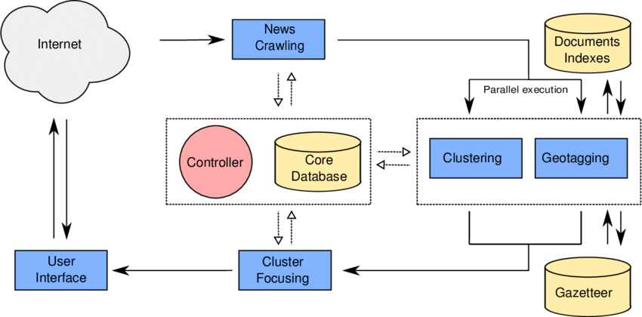

Figure 3.2: System architecture

## 

## 3.6.3 Input and Output Design

**VOICE CONTROLLED INTERFACE**

Latest News

Try Saying

Give me latest News

News by Categories

Categories:  
Business,

Try saying:  
Give me the latest Technology news

News by Terms

Terms:  
Bitcoin, PlayStation

Try saying:  
What's up with PlayStation 5

News by Sources

Sources:  
CNN, Wired, BBC News, Time

Try saying:  
Give me the news from CNN



Figure 3.3: Read News interface

**SEARCHED NEWS RESULT**

New

Article 1

New

Article 2

New

Article 3

New

Article 4

New

Article 7

New

Article 8

New

Article 9

New

Article 10

New

Article 5

New

Article 11

New

Article 6

New

Article 12



Figure 3.4: Searched News interface

## 3.7 System Requirement Specification

## 3.7.1 Hardware Requirements

The software to be design needs the following hardware for an effective operation of the newly designed system.

1. A system running on intel, P(R) duo core with higher processor
2. The-Random Access Memory (RAM) should be at least 512MB.
3. At least 20-GB hard disk.
4. A monitor.

## 3.7.2 Software Requirements

The software requirements include:

1. A window 7 or higher version of operating system.
2. XAMP or WAMP for Database
3. PHP
4. MySQL
5. Browser

## 3.7.3 Personnel Requirement

Any computer literate who has a technical knowhow of internet surfing can use the system because it is user friendly.

# CHAPTER FOUR

# RESULTS AND DISCUSSION

## 4.1 Introduction

The new system is designed using PHP and MySQL programming language for easy records inserting and updating. This system will help in managing and easily retrieving of information from the system for management purposes. The new system an AI Based Voice Controlled News Application.

## 4.2 Results

## 4.2.1 Welcome Interface

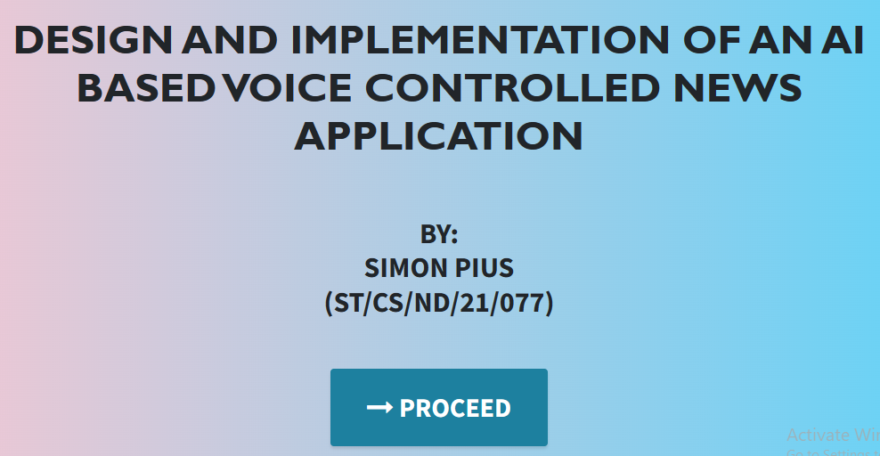

Figure 4.1: Welcome Interface

The above figure 4.2.1 shows the welcome page of the AI Based Voice Controlled News Application, the welcome page is the first page that displays on opening the program.

## 4.2.2 Voice Controlled Interface

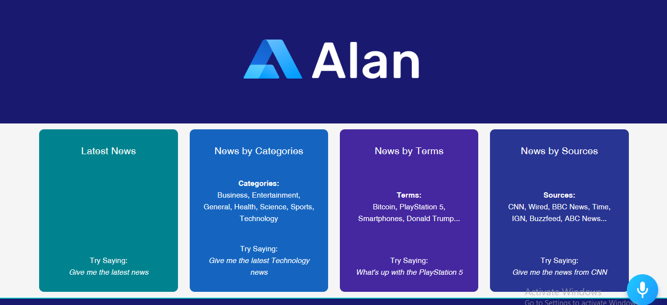

Figure 4.2: Voice Controlled interface

Figure 4.2.2 above shows the voice control instructions for the news reader application where a user can select a particular instruction to perform such as “Give me the Latest News”.

## 4.2.3 News Articles Interface

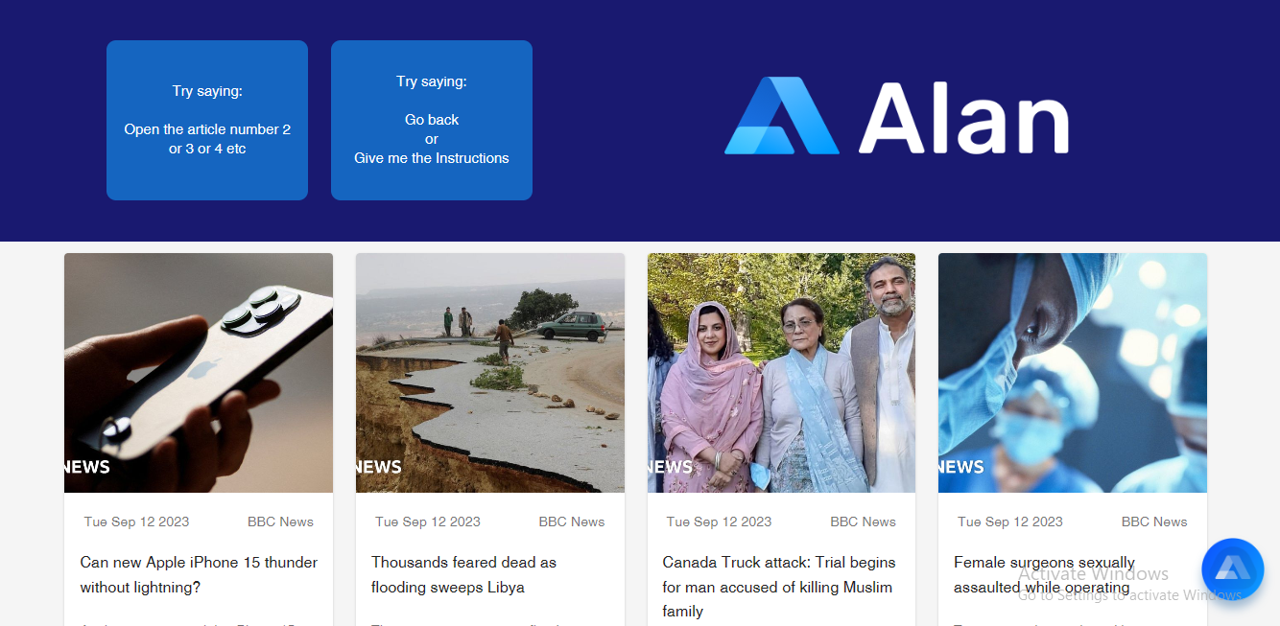

Figure 4.3: News Articles Interface

Figure 4.2.3 above shows the News articles interface where all articles concerning a particular searched term, source or category is displayed with numbering.

## 4.2.4 News Article Interface

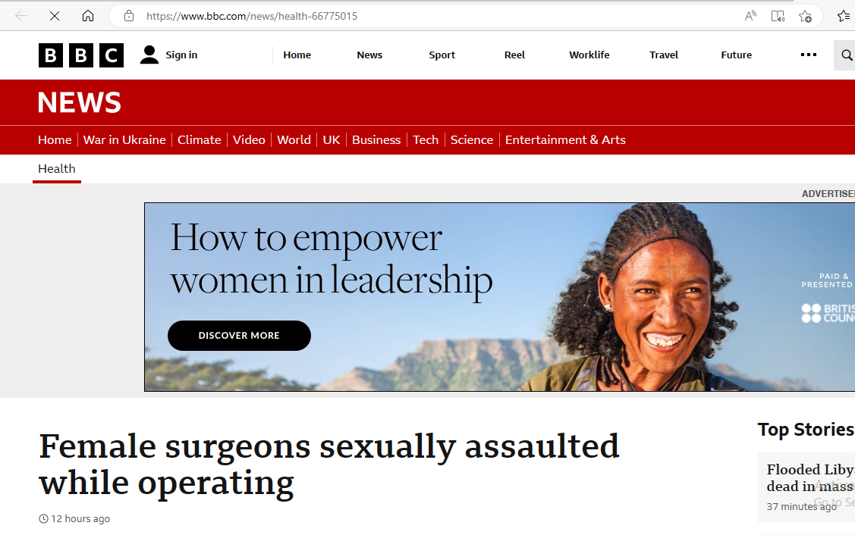

Figure 4.4: News Article Interface

Figure 4.4 above shows an opened article interface for a particular article that was given the command to open.

## 4.3 Discussion

Figure 4.1 Welcome Interface: The Welcome Interface serves as the entry point for users when they first launch the AI-based voice-controlled news application. Its primary purpose is to provide a user-friendly and engaging introduction to the application's capabilities. Greeting and Introduction: A friendly greeting message and a brief introduction to the application, explaining its core features and functionality. User Onboarding: Guided onboarding or a tutorial to help users understand how to interact with the application using voice commands. Voice Assistant Activation: A prominent button or voice trigger to activate the voice-controlled interface, making it clear that users can interact with the app using voice commands. Customization Options: Options for users to personalize their news preferences or set up their voice profile for accurate recognition. Visual Design: An appealing visual design that aligns with the application's branding, making a positive first impression.

Figure 4.2 Voice Controlled Interface: The Voice Controlled Interface is the core of the application, where users interact with the AI-powered voice assistant to control and access news content. Key features and functionalities of the Voice Controlled Interface include: Voice Activation: A listening mode that is activated when the user utters a wake word or presses a voice button, indicating their intent to communicate with the AI assistant. Voice Commands: A comprehensive list of voice commands that users can use to control the application, such as "Read the latest news," "Search for articles on technology," or "Bookmark this article." Voice Feedback: Clear and concise voice responses from the AI assistant, providing users with information, confirming commands, and assisting with navigation. Error Handling: Effective error handling that guides users when a command is not recognized or if there's an issue with the request. Contextual Understanding: The AI's ability to understand context, engage in natural conversations, and respond intelligently to user queries.

Figure 4.3 News Articles Interface: The News Articles Interface is where users browse and discover news content presented in a user-friendly format. Key components of the News Articles Interface include: Content Categories: Navigation options allowing users to explore news by categories like politics, technology, sports, and more. Featured Stories: Highlighted articles or breaking news stories displayed prominently at the top of the interface. Search Functionality: A search bar for users to find specific news articles or topics of interest. Filter and Sorting Options: Tools to filter news by relevance, date, popularity, or other criteria. Accessibility Features: Accessibility options, such as text-to-speech for visually impaired users, ensuring inclusivity.

Figure 4.4 News Article Interface: The News Article Interface is where users access and read individual news articles in detail. Key elements and features of this interface include: Full Article Display: The complete news article, including text, images, and multimedia content. Text-to-Speech: An option for the article to be read aloud by the AI assistant for users who prefer an auditory experience. Sharing and Bookmarking: Options for users to share articles on social media or bookmark them for later reading. Related Articles: Suggestions for related or similar articles to keep users engaged with relevant content. User Feedback: A mechanism for users to provide feedback on articles or report issues. Return to Voice Control: An option to return to the Voice Controlled Interface or perform voice commands related to the current article.

## 4.4 User manual

The following are the necessary steps to take in order to use the system efficiently and effectively.

1. Load the url of the system <https://localhost/news/> the welcome page will be displayed.
2. Click on the **Proceed** button to proceed to the main system.
3. Provide the necessary instruction for the Voice controlled News Application.
4. Depending on the instruction given the articles for the instruction will be listed pick a number to open the open.
5. The various task that you can perform will be displayed on the sidebar of the dashboard.

# CHAPTER FIVE

# SUMMARY, CONCLUSION AND RECOMMENDATIONS

## 5.1 Summary

In summary, the "Design and Implementation of an AI-Based Voice-Controlled News Application" represents a significant step forward in the realm of news consumption and user interaction. This innovative application leverages artificial intelligence and voice technology to provide users with a convenient, engaging, and personalized news experience. Through voice commands, users can effortlessly access, navigate, and interact with news articles while the AI assistant ensures accuracy and relevance. The application's design prioritizes user-friendliness, accessibility, and security, making it a promising solution for the evolving landscape of news delivery.

## 5.2 Conclusion

The development and deployment of this AI-based voice-controlled news application underscore the potential of AI and natural language processing in enhancing the way individuals access and engage with news content. The project demonstrates the feasibility of creating an intelligent and user-centric platform that caters to diverse user preferences and fosters informed citizenship. By bridging the gap between technology and news consumption, this application offers a promising avenue for the future of news delivery, empowering users to stay informed in a more accessible and interactive manner.

## 5.3 Recommendations:

Based on the implementation and user feedback, several recommendations can be made to further enhance the application's performance and user satisfaction:

1. Continuous Improvement: Regular updates and refinements to the AI algorithms and voice recognition capabilities to improve accuracy and understanding of user commands.
2. Content Partnerships: Collaborations with reputable news sources to expand the variety and depth of news articles available within the application.
3. Cross-Platform Integration: Integration with a broader range of voice-activated devices and platforms to reach a wider user base.
4. User Training and Support: Developing user guides and tutorials to help users make the most of the application's features.
5. Data Privacy Measures: Ensuring robust data privacy and security measures to protect user information and maintain trust.

## 5.4 Contribution to Knowledge

This project contributes to knowledge in several key ways:

Innovative Application: The development of an AI-based voice-controlled news application represents an innovative solution for news delivery, expanding the use of AI and voice technology in the field.

User-Centric Design: The emphasis on user-friendliness, accessibility, and personalized experiences contributes to the understanding of designing AI applications for broad user adoption.

Voice Interaction: The project advances knowledge about voice-controlled interfaces and their potential applications in the news industry and beyond.

## 5.5 Area for Further Work

Future work in this area could include:

Multilingual Support: Expanding language capabilities to cater to a global audience.

Enhanced Personalization: Further refining personalization algorithms to deliver even more tailored news content.

Voice Synthesis: Improving text-to-speech technology for a more natural and expressive voice experience.

AI Ethics: Continuously addressing ethical considerations related to AI, such as bias mitigation and responsible data usage.

User Engagement Analytics: Implementing advanced analytics to gain deeper insights into user engagement and preferences for continuous improvement.

# REFERENCES

Bajaj, A., Sharma, R., Bhatia, S., Chaturvedi, I., & Mehta, S. (2021). The Rise of Social AI: Building Engaging Conversational Agents with Personality. *arXiv preprint arXiv*:2106.15643.

Feng, F., Li, X., Zhu, F., Li, T., Zhang, Y., & Wang, C. (2020). News recommendation based on user preferences and behavior analysis. *Information Processing & Management*, 57(2), 102092.

Hasan, M. A., Bag, S., Ali, M., & Roy, R. (2021). A Context-aware Voice User Interface Framework for Multimodal Interaction. *Proceedings of the 14th International Conference on PErvasive Technologies Related to Assistive Environments*, 44-51.

Hassenzahl, M., & Tractinsky, N. (2006). User experience - a research agenda. *Behaviour & Information Technology*, 25(2), 91-97.

Huang, S., Xu, X., Wu, B., & Yu, P. S. (2021). Deep learning for voice recognition: A comprehensive review. *IEEE Transactions on Multimedia*, 23, 2195-2210.

Jurafsky, D., & Martin, J. H. (2020). *Speech and Language Processing* (3rd ed.). Pearson.

Li, J., Wang, H., Chen, Q., & Yang, J. (2021). Research on User Experience Design of News Portal Website Based on Web Responsive Technology. *Journal of Physics: Conference Series,* 1795(1), 012056.

Li, Y., Ding, Y., Jiang, W., & Huang, G. (2020). Evaluation of Voice Interface: Usability Testing Methods and Metrics. *Proceedings of the 2020 CHI Conference on Human Factors in Computing Systems,* 1-13.

Murthy, D. (2019). News consumption in the mobile era: Reaching audiences through augmented reality and smart speakers. *Digital Journalism,* 7(9), 1225-1242.

Nielsen, J., & Molich, R. (1990). Heuristic evaluation of user interfaces. *Proceedings of the SIGCHI conference on Human factors in computing systems*, 249-256.

Rietzler, M., Stieger, M., & Schwantner, M. (2021). Exploring multimodal feedback mechanisms for voice-driven animations in conversational agents. *Proceedings of the 2021 CHI Conference on Human Factors in Computing Systems*, 1-12.

Russell, S., & Norvig, P. (2016). *Artificial Intelligence*: A Modern Approach (3rd ed.). Pearson.

Sharma, N., Bhargava, D., Gupta, R., & Soni, A. (2021). Personalized news recommendation using hybrid collaborative filtering techniques. *Journal of Ambient Intelligence and Humanized Computing,* 12, 17957-17970.

Wang, Y., Wang, Z., & Liu, Y. (2020). Impact of Social Media Integration on User Engagement in Online News Portals. *Journal of Interactive Marketing,* 51, 75-88.

Wu, S., Tang, W., Wang, S., Yang, S., & Yang, F. (2019). Research on personalized news recommendation system based on deep learning. I*EEE Access,* 7, 170525-170537.

Wu, X., Zhu, J., Li, L., Wang, J., & Ma, Y. (2021). Voice-controlled news applications: An overview and future trends. *IEEE Access*, 9, 8261-8277.

Wu, Y., Liu, X., & Zhang, Y. (2019). Deep learning-based personalized news recommendation system. *Peer-to-Peer Networking and Applications*, 12, 2195-2206.

Zhang, Q., Cao, C., & Pados, D. A. (2022). Accent-Invariant Voice Recognition Based on Deep Learning. *IEEE Transactions on Audio, Speech, and Language Processing*, 30, 3636-3649.

Zhang, Y., & Ai, H. (2018). Artificial intelligence and voice recognition technologies: A review. *International Journal of Pattern Recognition and Artificial Intelligence,* 32(10), 1855011

Zhang, Y., Liu, J., Zhang, T., Liu, S., & Song, M. (2022). Credibility Assessment of News Articles Based on Machine Learning. *IEEE Transactions on Knowledge and Data Engineering*, 34(2), 637-651.

# APPENDIX A

Welcome Interface



Voice Controlled Interface



News Articles Interface



News Article Interface



# APPENDIX B

**PROGRAM CODE**

<!DOCTYPE html>

<html lang="en">

  <head>

    <meta charset="utf-8">

    <meta name="viewport" content="width=device-width, initial-scale=1, shrink-to-fit=no">

    <meta name="description" content="">

    <meta name="author" content="">

    <title>VOICE NEWS PROJECT</title>

    <!-- Bootstrap Core CSS -->

    <link href="vendor/bootstrap/css/bootstrap.min.css" rel="stylesheet">

    <!-- Custom Fonts -->

    <link href="vendor/font-awesome/css/font-awesome.min.css" rel="stylesheet" type="text/css">

    <link href="https://fonts.googleapis.com/css?family=Source+Sans+Pro:300,400,700,300italic,400italic,700italic" rel="stylesheet" type="text/css">

    <link href="vendor/simple-line-icons/css/simple-line-icons.css" rel="stylesheet">

    <!-- Custom CSS -->

    <link href="css/stylish-portfolio.min.css" rel="stylesheet">

  </head>

  <body id="page-top" style=" background: linear-gradient(90deg, pink, rgb(67, 207, 250));">

    <!-- Header -->

    <header class="masthead d-flex">

      <div class="container text-center">

        <h1 class="mb-2" style="font-size: 45px; font-weight: bolder; font-family: 'Gill Sans', 'Gill Sans MT', Calibri, 'Trebuchet MS', sans-serif; text-transform: uppercase;"><span style=" margin-top:15px;"> DESIGN AND IMPLEMENTATION OF AN AI BASED VOICE CONTROLLED NEWS APPLICATION</span> <br>  </h1>

        <h2 class="mb-3" style=""></h2><br><br>

        <h2>BY: <br> SIMON PIUS <br> (ST/CS/ND/21/077)</h2> <br>

        </h3>

        <br>

        <strong><a class="btn btn-primary btn-xl js-scroll-trigger" href="https://alan-ai-by-rk.netlify.app/" style="font-size: 30px;"><span class="fa fa-long-arrow-right"></span> PROCEED</a></strong>

        <br> <br> <br>

        <!-- <h4 class="alert alert-success"><a href="onlinefood-order/admin/index.php">Admin Login Here!</a></h4> -->

              </div>

      <div class="overlay"></div>

    </header>

    <!-- Scroll to Top Button-->

    <a class="scroll-to-top rounded js-scroll-trigger" href="#page-top">

      <i class="fa fa-angle-up"></i>

    </a>

    <!-- Bootstrap core JavaScript -->

    <script src="vendor/jquery/jquery.min.js"></script>

    <script src="vendor/bootstrap/js/bootstrap.bundle.min.js"></script>

    <!-- Plugin JavaScript -->

    <script src="vendor/jquery-easing/jquery.easing.min.js"></script>

    <!-- Custom scripts for this template -->

    <script src="js/stylish-portfolio.min.js"></script>

  </body>

</html>

import React from 'react';

import { Grid, Grow, Typography } from '@material-ui/core';

import NewsCard from '../NewsCard/NewsCard';

import useStyles from './styles.js';

const infoCards = [

  { color: '#60838f', title: 'Latest News', text: 'Give me the latest news' },

  { color: '#042131', title: 'News by Categories', info: 'Business, Entertainment, General, Health, Science, Sports, Technology', text: 'Give me the latest Technology news' },

  { color: '#052640', title: 'News by Terms', info: 'Bitcoin, PlayStation 5, Smartphones, Donald Trump...', text: 'What\'s up with PlayStation 5' },

  { color: '#277596', title: 'News by Sources', info: 'CNN, Wired, BBC News, Time, IGN, Buzzfeed, ABC News...', text: 'Give me the news from CNN' },

];

const NewsCards = ({ articles, activeArticle }) => {

  const classes = useStyles();

  if (!articles.length) {

    return (

      <Grow in>

        <Grid className={classes.container} container alignItems="stretch" spacing={3}>

          {infoCards.map((infoCard) => (

            <Grid item xs={12} sm={6} md={4} lg={3} style={{display:'flex'}} className={classes.infoCard}>

              <div className={classes.card} style={{ backgroundColor: infoCard.color }}>

                <Typography variant="h5" component="h5">{infoCard.title}</Typography>

                {infoCard.info ? <Typography variant="h6" component="h6"><strong>{infoCard.title.split(' ')[2]}</strong>: <br />{infoCard.info}</Typography> : null}

                <Typography variant="h6" component="h6">Try saying: <br /> {infoCard.text}</Typography>

              </div>

            </Grid>

          ))}+

        </Grid>

      </Grow>

    );

  }

  return (

    <Grow in>

      <Grid className={classes.container} container alignItems="stretch" spacing={3}>

        {articles.map((article, i) => (

          <Grid item xs={12} sm={6} md={4} lg={3} style={{ display: 'flex' }}>

            <NewsCard activeArticle={activeArticle} i={i} article={article} />

          </Grid>

        ))}

      </Grid>

    </Grow>

  );

};

export default NewsCards;

import React, { useState, useEffect, createRef } from "react";

import {

  Card,

  CardActions,

  CardActionArea,

  CardContent,

  CardMedia,

  Button,

  Typography,

} from "@material-ui/core";

import useStyles from "./styles";

const NewsCard = ({

  article: { description, publishedAt, source, title, url, urlToImage },

  activeArticle,

  i,

}) => {

  const classes = useStyles();

  const [elRefs, setElRefs] = useState([]);

  const scrollToRef = (ref) => window.scroll(0, ref.current.offsetTop - 50);

  useEffect(() => {

    window.scroll(0, 0);

    setElRefs((refs) =>

      Array(20)

        .fill()

        .map((_, j) => refs[j] || createRef())

    );

  }, []);

  useEffect(() => {

    if (i === activeArticle && elRefs[activeArticle]) {

      scrollToRef(elRefs[activeArticle]);

    }

  }, [i, activeArticle, elRefs]);

  return (

    <Card

      ref={elRefs[i]}

      className={activeArticle === i ? classes.activeCard : classes.card}

    >

      <CardActionArea href={url} target="_blank">

        <CardMedia

          className={classes.media}

          image={

            urlToImage ||

            "https://www.industry.gov.au/sites/default/files/August%202018/image/news-placeholder-738.png"

          }

          title={title}

        />

        <div className={classes.card}>

          <Typography variant="body2" color="textSecondary" component="h2">

            {new Date(publishedAt).toDateString()}

          </Typography>

          <Typography variant="body2" color="textSecondary" component="h2">

            {source.name}

          </Typography>

        </div>

        <Typography

          className={classes.title}

          gutterBottom

          variant="h5"

          component="h2"

        >

          {title}

        </Typography>

        <CardContent>

          <Typography variant="body2" color="textSecondary" component="p">

            {description}

          </Typography>

        </CardContent>

      </CardActionArea>

      <CardActions className={classes.cardActions}>

        <Button size="small" color="primary" href={url}>

          Learn More

        </Button>

        <Typography variant="h5" color="textSecondary" component="h2">

          {i + 1}

        </Typography>

      </CardActions>

    </Card>

  );

};

export default NewsCard;